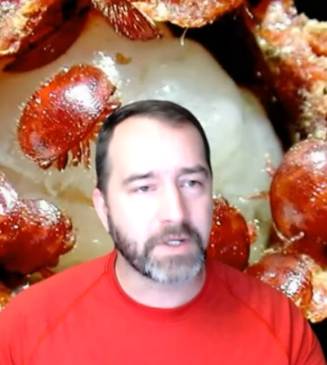
Dr. Frank D. Rinkevich is a Research Entomologist at the USDA-ARS Honey Bee Breeding, Genetics, and Physiology Laboratory in Baton Rouge LA. Frank has extensive training in insect toxicology, and genetics. The goal of Dr. Frank's research is to provide a basic understanding of pesticide toxicology that is relevant to field conditions in the commercial beekeeping industry. Current research interests in Dr. Rinkevich's lab include determining the breadth, depth, and mechanisms of amitraz resistance in Varroa, evaluating the effects of pesticide exposure on colony survivorship in commercial beekeeping operations, establishing the effects of fungicides on colony health, and evaluating the performance of honey bee stocks selected for low Varroa populations in commercial beekeeping conditions.
Frank will share with SBDC attendees the latest about reported high bee mortality experienced in the USA in 2025 and options for improving bee health.
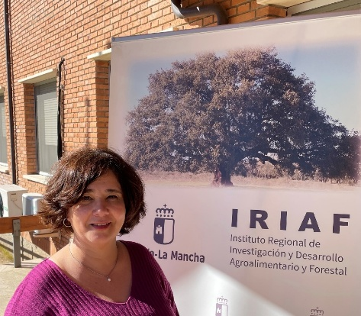
Dr. Raquel Martín Hernández is veterinarian and holds a doctorate in veterinary medicine. Her professional activity has mainly developed on research in entomology applied to animal health, in which she has 30 years of experience, although her main activity is focused on bee health. Her research activity is carried out at the Beekeeping and Agro-environmental Research Center (CIAPA-IRIAF) in Marchamalo, Spain. She has participated in numerous publicly funded research projects, serving as principal investigator in 10 of them, three of which funded by the European Union. She has attended numerous national and international conferences and has collaborated on the organizing committee of three them. Her research work has been published in 150 scientific journals, seven books or monographs, and 22 extension articles. She has co-directed ten doctoral theses and is currently supervising two others. She collaborates regularly with agencies and research centers in different countries and is a project evaluator for national and international agencies, including EU calls and COST actions. Raquel will share with us her experience son Varroa and impacts of viruses’ landscape in honey bees including Varroa management in Spain. She will also share her perspectives on Nosema ceranae biology, diagnostics and control in honey bees

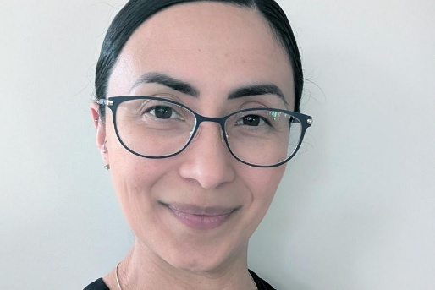
Dr, Nuria Morfin, Assistant Professor, Department of Entomology, University of Manitoba, Winnipeg, MB. She s also the Chair of the BC Technology Transfer Program. Nuria has fourteen years of experience as an extensionist – acting as a link between research and industry. She has expertise in diverse areas, including Integrated Pest Management (IPM), selective breeding, and honey bee pathology. Nuria has collaborated in a number of research projects in North America, has published in reputable scientific journals, and has been an instructor of IPM, queen rearing, and honey bee biology courses. Nuria got her PhD from the University of Guelph – Honey Bee Research Centre, where she later worked as a researcher studying the impact of stressors on health and behaviour, analyzing the mechanisms behind behavioral immunity, and studying the lipidome and metabolome profile of bees. Nuria also worked as a Bee Inspector for the Ontario Ministry of Agriculture, Food and Rural Affairs (OMAFRA). Throughout her career, she has been actively contributing to apicultural research and industry. Nuria will share with the SK AGM attendees her studies on varroa injury thresholds as well as impacts of pathogens, parasites and environment on honey bees.

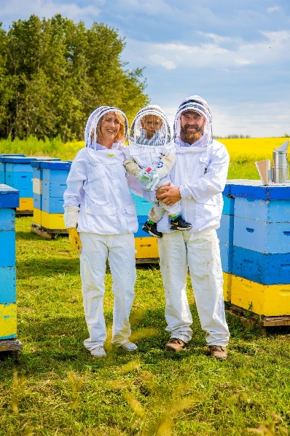
Lorne Prins

The Gull Lake Honey company is Owned & Operated by Lorne & Alida Prins. Listen to our beekeeping origin story, from when Lorne quit his career in construction management almost a decade ago, and set out on the wild adventure of commercial beekeeping. Follow along as Lorne discusses the ups and downs of going from 0-3000 hives, as well a developing a robust queen production and nuc program, with the ultimate goal of Self sufficiency.

