Quality Queen Rearing Short Course

Organizers: Saskatchewan Beekeepers Development- Tech Adaptation Program and Saskatchewan Ministry of Agriculture

Dates:
- June 5, 2026. (In person in the field: 9:00 am- 4:30 pm)

Location: Field Day will be in Shellbrook, SK. The location will be provided later

This course is designed for those who want to learn how to rear honey bee queens or improve their skills for producing quality queens. This is a 1-day course. It will be hands on class in the field to practice preparing queen cell builders, preparing cell cups, grafting, making mating nuclei, harvesting mated queens. Every participant will have a chance to try grafting larvae and raising queens. Breeding and selection quality bees will be discussed.

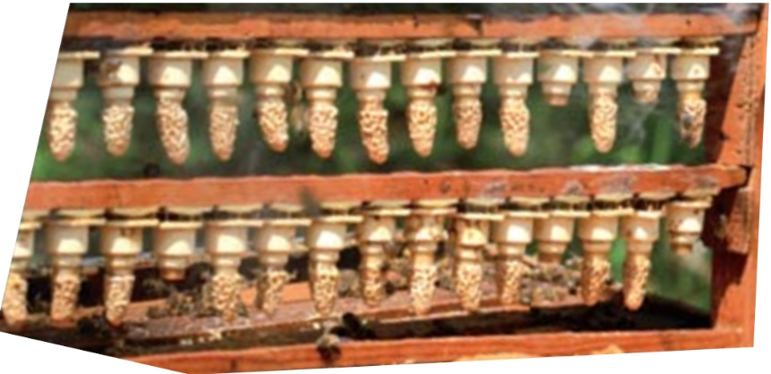
Prerequisite: At least two years of beekeeping experience.

Cost of the course: The cost for course is $225.00 which includes, a copy of “Queen Rearing Essentials” by Dr. Lawrence John Connor, lunch during the field day, and refreshments.

Instructors:
- Geoff Wilson, Provincial Apiculturist, Saskatchewan Ministry of Agriculture.
- Medhat Nasr, Saskatchewan Beekeepers Development Commission -Tech Adaptation Program Lead.
- Graham Parson, Pollinator Biosecurity Specialist, Saskatchewan Ministry of Agriculture.

This short course is limited to only 10 students and typically fills up quickly!

Sign up now to get a spot in the short course

